11.3.5 Editors - Shader Editor - Sidebar - Iconortext, Input and Modify
Iconortext Tab 1
Input and Modify Tab 1
Usage 1

Iconortext Tab

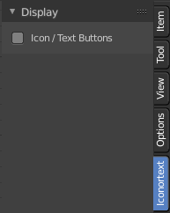
This tab contains a display panel that affects if the following panels Input, Modify and Relations will show text buttons or pure icon buttons.

Input and Modify Tab
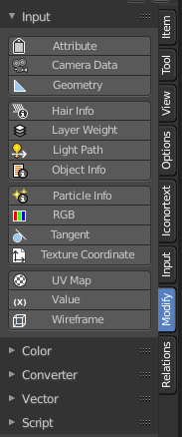
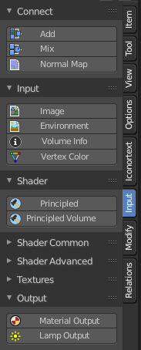
Here you can find the same nodes than in the Add menu. They are a bit different organized to have the most used nodes at the top. And a panel stays open. Which makes the usage of this menu content easier. It's your decision with what system you want to work.

The appearance can be adjusted in the Iconortext tab. Either text buttons with icons. Or pure icon buttons.

We won't explain the content of the panels again. The single nodes are explained in the add menu chapter.

Usage
Click at one of the node buttons, then move the mouse into the viewport. The created node sticks at the mouse. Click again to release it.

